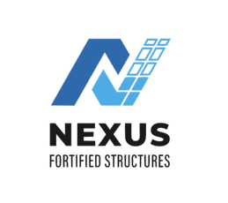
Nexus certificate of completion
Forklift & Boomlift Operator Certificate

This Certificate Acknowledges

OPERATOR NAME
EQUIPMENT COVERED:
ROUGH TERRAIN FORKLIFT [CLASS VID, TELEHANDLER]

has successfully completed site-specific forklift training, including safe operation in construction environments with variable contain

Training Completed: 01/03/2025-Valid until 01/03/2028
Duration: Hours [4 Hours Theory/4 Hours Practical]
Certificate ID: NFS-

Certifying Officer

Certifying Officer

